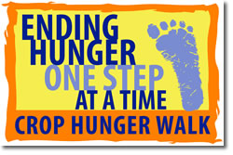**38th Annual CROP Hunger Walk**

**Sunday, October 13, 2019**

**Gring’s Mill Recreation Area**

**Registration begins at 12:30 PM**

**Walk begins at 1:30 PM**

This is our **38th year** for the Reading-Berks CROP Hunger Walk and we have raised more than a MILLION DOLLARS over the years!

This year’s goal will be to raise  **$27,000** ! Here are some ways you can help!

**Organize a team to walk** – Assign someone to be your congregation’s walk coordinator and get a group of folks together who will walk on October 13th. People of all ages can be involved. You walk at your own pace – be it a leisurely stroll or a full out run! Walkers can choose a 1-mile, 3-mile or 5-mile loop (approximately) depending on their ability.

**All walkers are asked to collect money from sponsors and bring it to the event.** (**Walkers who collect at least $100 in sponsorships will receive a free event t-shirt!)** Online donations can also be made at: [www.crophungerwalk.org](http://www.crophungerwalk.org)/readingpa

75% of the money raised goes to support Church World Service’s mission to feed hungry people around the world by helping them develop self-sustaining methods of growing crops and raising livestock. 25% of the money raised will go to Helping Harvest (formerly the Greater Berks Food Bank), which provides food locally for those in need. Encourage folks to share information about the Walk with their Facebook friends and share the link for them to donate online.

**Come eat at Isaac’s on Thursday, September 5th -** You can help raise money to fight hunger just by eating! **This year we will be at Isaac’s for lunch and dinner!** Bring a group of friends and family to Isaac’s in the Village Square in Wyomissing. Isaac’s will give **25%** of meal costs (for anyone presenting a coupon) to our CROP Hunger Walk. Please copy the enclosed coupons and hand out at church, in your neighborhood, and at work! This is a great kick-off for our event - last year we received **$ 775** from this fundraiser! **All Walk materials will be available for pick-up at Isaac’s that day from 11:00 AM to 8:30 PM.**  We will also be able to help you **register your team online** if you haven’t done so yet.

If you have questions or need more information, please call Dawn at 610-375-8303 or go to [www.crophungerwalk.org](http://www.crophungerwalk.org)/readingpa OR … *(see next page)*

**New for 2019 - we have a Facebook page! Reading Berks CROP Walk**

This link will get you there: <https://www.facebook.com/Reading-Berks-CROP-Hunger-Walk-332030921042472/>

You should also be able to copy and paste this QR code:



When you zoom in on this with a smart phone camera it will take you to the Facebook page.

**2018 CROP Walk Report** – Total Amount Raised was **$25,872.** Great job everybody!

Our goal this year, for our 38th Annual CROP Walk, is **$27,000!** We can do it!

***Golden Sneaker Award*** for most walkers: **St. Paul’s UCC in Fleetwood - 25 Walkers**!

***Benevolent Bling Award*** for most funds raised - **West Lawn United Methodist - $3,122!**

**St. Paul’s UCC in Fleetwood** alsowon the ***Funky Flip Flop Award*** for most **youth** walking.

**We are hoping to make this year’s CROP Hunger Walk the best ever and we’re sure you’ll want to help as we work together to end hunger – one step at a time!**

The Reading-Berks CROP Hunger Walk Planning Team

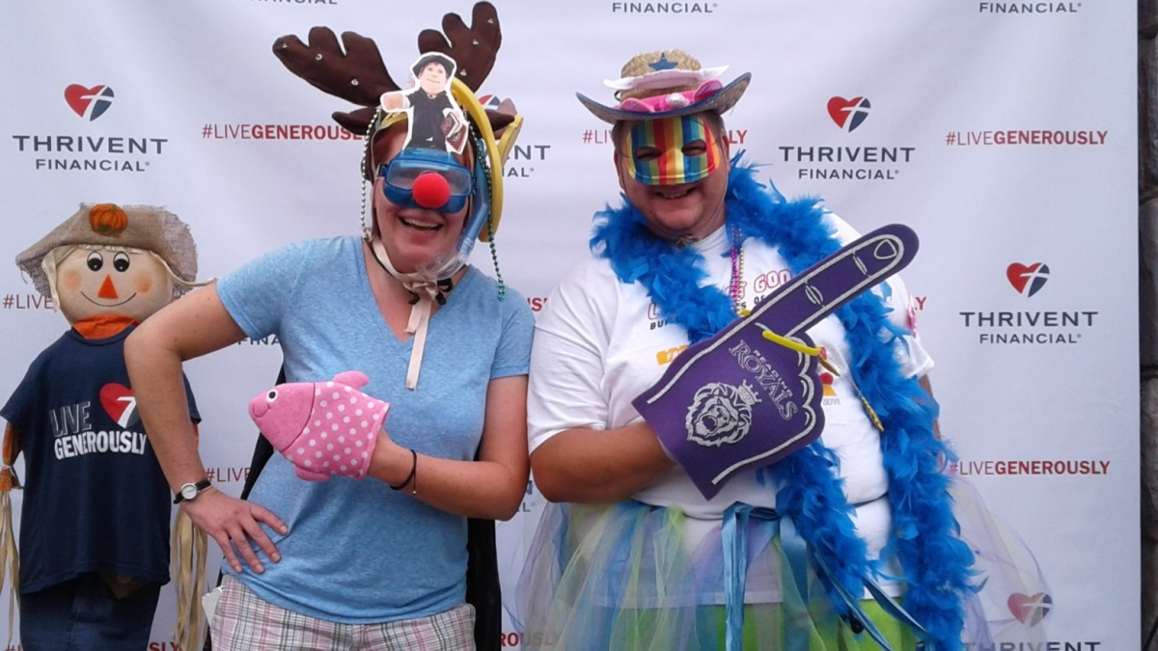

You just never know who might be walking in the

Reading-Berks CROP Hunger Walk!