Calling All Youth in Grades 5-12!
It’s time for the WBMD 2020 Youth Event
“Making a Difference Step by Step”
Saturday, February 29 - 9:00 AM to 4:30 PM
Hosted by Allegheny Lutheran Church in Knauers
We are collecting gently worn shoes and boots of all sizes and styles for the non-profit, In Ian’s Boots, and will be traveling to Pottstown to serve at their warehouse!

Cost for the event is $25
Event will include: games, music, worship, activities, service, food and FUN!

Deadline for registration is February 20th! Register through your congregation’s youth leader or by calling the WBMD at 610-375-8303 or emailing dawn@westberksmissiondistrict.org
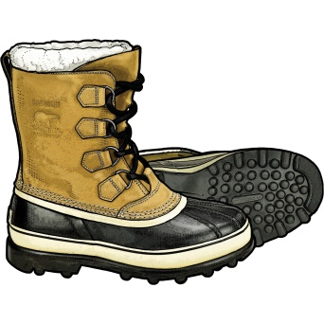

What might it be like - walking in someone else’s shoes???
for clean water… for medical care… for food…

