CAMP NOAH – 2021

Kids have had uncertainty in their lives this past year in the midst of a pandemic. Camp Noah is a unique educational experience nurturing skill for life: coping with stress, healing from loss, restoring hope. We will play games, do crafts, share stories, celebrate campers, eat good food, restore relationships, and be community in a Covid-safe, outdoor setting with professional leaders.
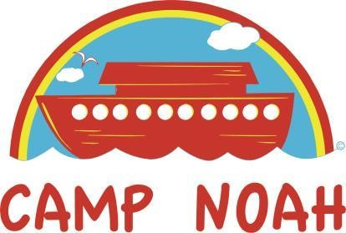
August 2-6, 2021, 9a-3p daily
Breakfast served 8:30a-9a (revised)

@ Oley Fairgrounds
26 Jefferson St, Oley, PA 19547
Transportation assistance available upon request.
To volunteer or ask questions contact:
- Volunteers: Kathy Schaeffer KSchaeffer@friedenslutheran.org 610-987-6021
- Financial/In-Kind Donations Individual /Business Sponsors: Rebecca Knox RevKnox7@gmail.com 610-823-8343

Cash, Checks and electronic donations welcome:
Frieden’s Lutheran Church
“Camp Noah” in memo line
1076 Memorial Hwy, Oley, PA 19547
Friedenslutheran.org
select ‘Camp Noah’ option

For Children who have completed
K-5th grades. (revised)
Campers attend FREE! All food, materials, t-shirt… Included!
*Registration info below (type or scan): app.campdoc.com/register/campnoah

